Sprint 3 - Agility Design Document

November 29, 2022

Table of Contents

1. Executive Summary 3

1.1 Project Overview 3

1.2 Purpose and Scope of this Specification 3

2. Product/Service Description 3

2.1 Product Context 3

2.2 User Characteristics 3

2.3 Assumptions 3

2.4 Constraints 3

2.5 Dependencies 4

3. Requirements 4

3.1 Functional Requirements 5

3.2 Security 5

3.2.1 Protection 5

3.2.2 Authorization and Authentication 6

3.3 Portability 6

4. Requirements Confirmation/Stakeholder sign-off 6

5. System Design 6

5.1 Algorithm 6

5.2 System Flow 6

5.3 Software 6

5.4 Hardware 6

5.5 Test Plan 7

5.6 Task List/Gantt Chart 7

5.7 Staffing Plan 7

# Executive Summary

## Project Overview

The robot agility project is a project for the CS-104 class. In the agility section of the project, a robot must travel around a course without colliding with anything or going off course. The intended audience of this project is CS-104 students, who are learning how to code, and instructors who are overseeing the students.

***Purpose and Scope of this Specification***

This document is intended for the agility section of the robot project

In scope

* Agility section of the robot project.

Out of Scope

* Accuracy section of the robot project.
* Endurance section of the robot project.

# Product/Service Description

## Product Context

The agility section of the robot project slightly differs from the other two sections. The main difference between each of the sections is the courses the robots are required to follow. Each section has a different aim, which the unique course addresses.

## User Characteristics

* Students
* Instructors
* People interested in learning how to code
* People interested in learning Sphero robots

## Assumptions

* We assume we will have a device that runs iOS.
* We assume the room will be available in order test the program

## Constraints

* Block code is limited
* Sphero is very simple

## Dependencies

* This project requires a Sphero robot
* The project requires users to download the Sphero interface
* Howard Hall room 208 must be available in order to test the program
* The user must be running iOS to view the sensor data

# Requirements

## Functional Requirements

| **Req#** | **Requirement** | **Comments** | **Priority** | **Date Rvwd** | **SME Reviewed / Approved** |
| --- | --- | --- | --- | --- | --- |
| AGILIT_01 | Robot must complete the obstacle course |  | 1 | 11/28 | Approved |
| AGILIT_02 | Robot must avoid each of the three glass bottles |  | 1 | 11/28 | Approved |
| AGILIT_03 | Robot must go over the ramp |  | 1 | 11/28 | Approved |
| AGILIT_04 | Robot must knock over as many pins as possible |  | 1 | 11/28 | Approved |

## Security

### Protection

* Must login in order to access the account which the code is on.

### Authorization and Authentication

Must login in order to access the account which the code is on.

## Portability

* Can access code on any device, given that you login
* Can only see certain aspects of program based on operating systems
* Only iOS can view sensor data
* The robot will behave the same no matter which device it is controlled from

# Requirements Confirmation/Stakeholder sign-off

|  |  |  |
| --- | --- | --- |
| Meeting Date | Attendees (name and role) | Comments |
| 11/28/2022 | Kevin, Emma, Vincent | confirmed all requirements |

# System Design

## Algorithm

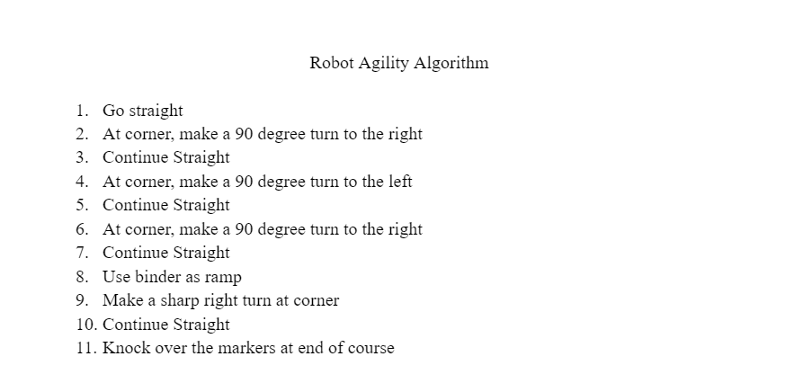

## System Flow

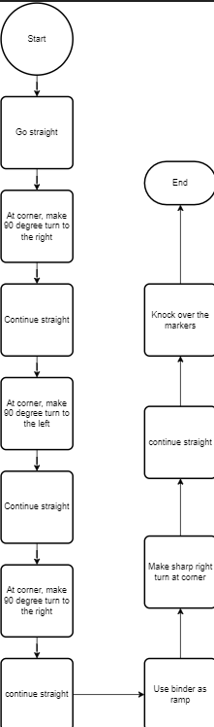

## Block Code and Sensor Data

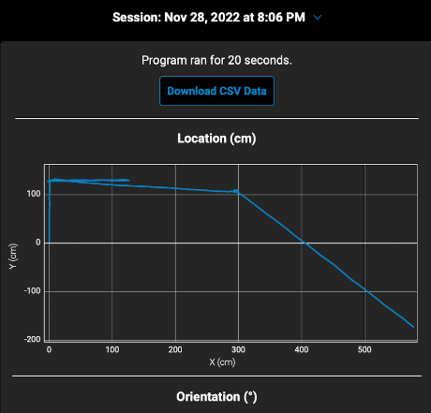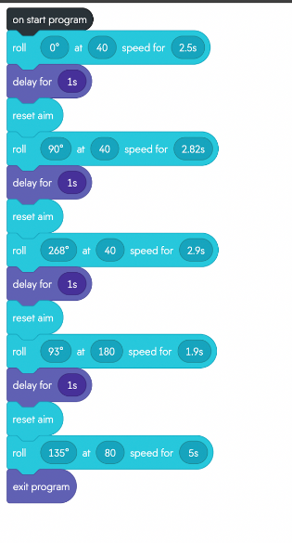

## Software

The robot was programmed using block code.

## Hardware

The robot was coded on the Sphero program.

## Test Plan

Include a test plan showing all unit tests performed for this application, Include test rational, test date, staff member, pass/fail status

| **Reason for Test Case** | **Test Date** | **Expected Output** | **Observed Output** | **Staff Name** | **Pass/Fail** |
| --- | --- | --- | --- | --- | --- |
| Testing to see if the robot will follow the first diagonal line. | 11/28/22 | Robot follows the first diagonal line | Robot was able to follow the line but went too long. | Kevin | Fail |
| After editing the code, the robot will successfully go one diagonal line. | 11/28/22 | Robot should go the full length of the first line and no farther. | Robot followed the line successfully | Kevin | Pass |
| Add onto the code, change the angle at which the robot will go down the second angle. | 11/28/22 | The robot should follow the first two diagonal lines. | The robot was able follow the first to zig zag lines. | Kevin | Pass |
| Testing to see if the robot will go through the 3 zig zag lines before the ramp. | 11/28/22 | Robot should successfully follow the zig zag. | Robot was able to follow all of the lines and stop before the ramp. | Kevin | Pass |
| See if the robot will go over the ramp. | 11/28/22 | The robot should go over the ramp. | The robot passed this test and went over the ramp and remained on the tape. | Kevin | Pass |
| After completing the course, the robot now knocks down all of the pins. | 11/28/22 | The robot should knock down all ten pins. | The robot knocked 6/10 pins over. | Kevin | Fail |
| The robot should knock down ten pins after making edits to the code. | 11/28/22 | The robot should knock down all ten of the pins. | The robot successfully completed the task. | Kevin | Pass |

## Task List/Gantt Chart

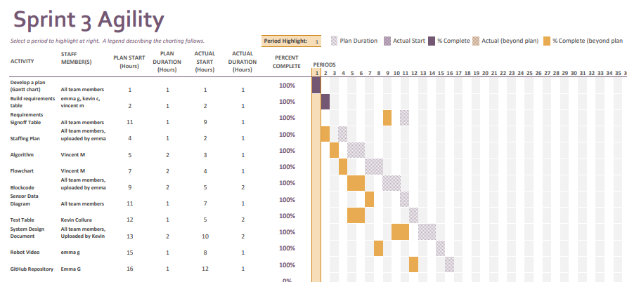

## Staffing Plan

| Name | Role | Responsibility | Reports To |
| --- | --- | --- | --- |
| Emma Green | Videographer, repository creator! | Make robot video, upload block code, create staff plan | Vincent |
| Kevin Collura | Documenter | Document items in the system design document, fill out test table during robot testing | Vincent |
| Vincent Macri | Manager | Manage the project, make sure everything gets done, commit to GitHub repository. Also working on flowchart. | Myself |